Review Meeting- 045
Gaurang Garg
H-ORG Lab, Centre for Biomedical Engineering, IIT Delhi
2026-03-11 (Wednesday)
Title: Simulation of Low-resolution images captured through a low NA objective of a high-resolution object on illumination by an LED array placed some distance away from it.
Abstract: Computational simulation based on Forward model of generating low-resolution intensity images of a high-resolution object if captured through an objective lens of low NA when illuminated by an LED square matrix placed at a distance away from the object is accomplished. For the simulation, 0.1 NA objective and 7x7 LED array is considered which generates 49 intensity images.

1. Introduction
Fourier Ptychography microscopy uses low resolution intensity images to retrieve the high-resolution object function by using phase retrieval algorithms. These low-resolution images are on account of low NA objective lens used for its wide Field-of-view. We first simulate and understand the capturing of these low-resolution images through a high-resolution object of our choosing.
The core challenge in optical microscopy is the diffraction limit. A low Numerical Aperture (NA) objective lens acts as a low-pass filter, discarding high-frequency spatial information (fine details) and resulting in a blurred image.
In FPM, we overcome this by illuminating the sample from multiple angles using an LED array. Each angle corresponds to a specific spatial frequency shift in the Fourier domain. By shifting the sample's spectrum, we allow high-frequency information that would normally fall outside the lens's aperture to pass through it.

1.1. Mathematical Framework
For an object $O\left(r\right)$ illuminated by a plane wave with wavevector${ k}_{i}$, the field exiting the sample is:
$$ψ_{exit}\left(r\right)=O\left(r\right)⋅\exp\left(jk_{i}⋅r\right)$$ | (1)
In the Fourier domain, this multiplication becomes a shift:
$$Ψ_{lens}\left(k\right)=F\{O\left(r\right)\}*δ\left(k-k_{i}\right)=\hat{O}\left(k-k_{i}\right)$$ | (2)
The objective lens then applies its Pupil function $P\left(k\right)$ (the low-pass filter):
$$Ψ_{camera}\left(k\right)=\hat{O}\left(k-k_{i}\right)⋅P\left(k\right)$$ | (3)

1.2. Simulation Parameters
The simulation reflects a specific laboratory configuration:
- Objective: $0.1$ NA, $18\text{mm}$ working distance (focus).
- Illumination: $7 ×7$ LED array, $4\text{mm}$ pitch, placed $80\text{mm}$ below the object.
- Wavelength: $532\text{nm}$ (Green).
The $80\text{mm}$ distance is critical because it defines the angle of incidence $θ$ for each LED. The spatial frequency shift is calculated as:
$$k_{x}=\frac{\sin\left(θ_{x}\right)}{λ}=\frac{Δx/\sqrt{Δx^{2}+Δy^{2}+h^{2}}}{λ}$$ | (3)

2. Code Design
- Object Creation: We generate a complex field. In microscopy, samples are not just manipulating intensity (amplitude); they also delay light (phase). For our simulation, the amplitude is represented by standard cameraman image and phase by standard moon image. They are mathematically expressed as an Object function $Obj_{HR}=A⋅e^{jϕ}$
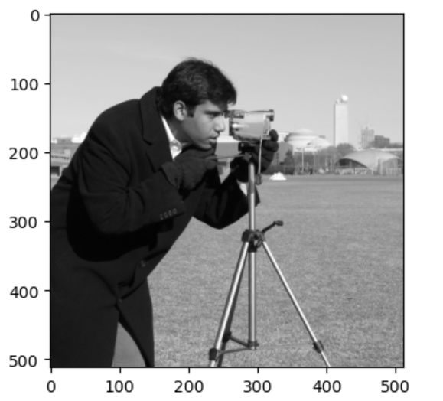
Figure 1 Amplitude for the object function
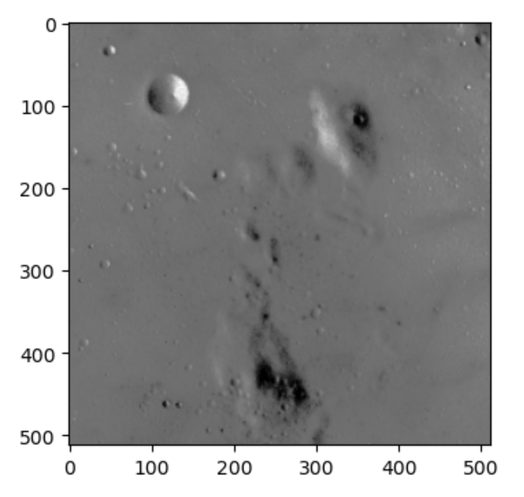
Figure 2 Phase for the object function
- The Pupil Function: We define a $k-$space grid where the center represents the DC (zero frequency) component. The pupil function is a low-pass filter. Since our NA is only $0.1,$ the objective can only allow frequencies inside a small circle in the center of the Fourier spectrum given by
$$k_{cutoff}=NA/λ$$ | (4)
K values satisfying this condition will pass through this filter.
- LED Shift Calculation: Define a matrix corresponding to the Led array size and the spatial coordinates for the LED by multiplying the pitch of the array which is 4mm.

- Phase Shift: For each tilted illumination, we multiply the object with a phase factor $\exp\left(j2π\left(k_{x}x+k_{y}y\right)\right)$, this is mathematically equivalent of shifting the spectrum in Fourier space.

- Fourier Transformation: We move the shifted object into the frequency domain using the Fast Fourier Transform (fft2). This represents the light field at the back focal plane of the objective. We multiply the pupil function to the shifted transform and inverse it back to spatial domain.

- Intensity Measurement: The camera cannot see phase; it only sees the squared magnitude of the field. This is why the LR images look blurry, we have lost the high-frequency edges and the phase information.

Results:
The simulation generated 49 low resolution intensity images corresponding to 7x7 LED grid placed 8cm away from the object. The parameters are simulated as per th e reference paper [1]. Here are some LR images:
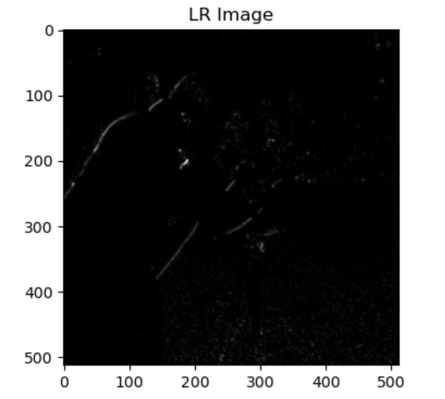
Figure 3 LR image for outermost LED
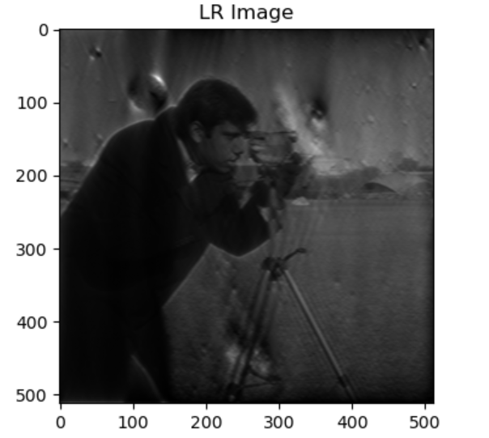
Figure 4 LR image for second row middle LED
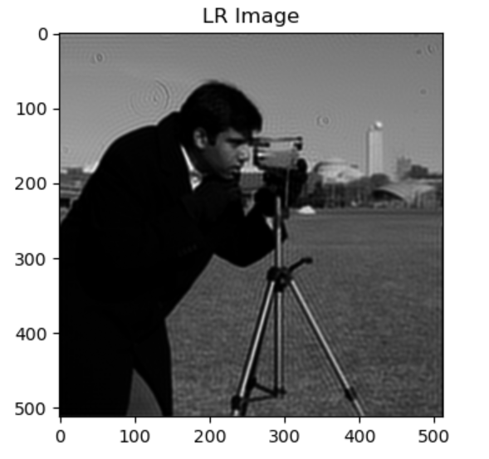
Figure 5 LR image for middle LED (on-axis)

References:
1. "Wide-field, high-resolution Fourier ptychographic microscopy | Nature Photonics," https://www.nature.com/articles/nphoton.2013.187.

